**Unmanned Moving Vehicle for Detection of Gas Leakage and Pollution using IoT**

1. Elavarasi.N, 1Geethanjali.M, 1Indhuja.R.P, 2Kanmani.R 1Student, 2 Assistant professor

Department of Electronics and Communication Engineering Sri Ramakrishna Institute of Technology, Coimbatore-641010

[indhujarps11@gmail.com](mailto:indhujarps11@gmail.com)

[elavarasividhya0@gmail.com](mailto:elavarasividhya0@gmail.com)

[kanmani.ece@srit.org](mailto:kanmani.ece@srit.org)

***ABSTRACT:***

*A wireless safety system for detection of gas leakage is proposed. The detection system is used to avoid accidents due to leakage of gases in household areas or in industrial areas. The leaked gases when ignited may leads to explosion. This project focuses on detection of gas leakage using* ***CC3200.*** *An Unmanned moving vehicle is attached with gas sensors like carbon monoxide, ammonia, LPG and smoke sensor is continuously roaming around particular area, in order to recognize the gas leakage. The gas leakage can be easily monitored and detected by the sensors that are embedded on the moving vehicle. A particular gas level is fixed as a threshold level, If the detected gas concentration exceeds the*

*threshold value then it is assumed to be polluted, the system will inform by activating a buzzer. The notification will be sent to the user about the gas level through IOT. So this project helps in identifying the leakage which in turn reduces the pollution.*

*Keywords –internet of things, gas leakage detector, unmanned moving vehicle model, gas sensor, air pollution monitoring.*

**INTRODUCTION:**

IOT is an ecosystem of physically connected objects which can be accessed from the internet. Internet of Things plays an important role in technology industries and engineering circles. This technology offers the possibility of transferring the

information along the value chain of production using networked sensors. [4]

In a growing population we were facing so many problems, among that pollution is one of the major cause .The polluted air mix in the environment and it affects the surroundings. If the people use the water or inhale the contaminated air it leads to many health issues and its danger for the present and future generation.

Gas is highly combustible. Correctly fitted and maintained gas appliances ensure that gases is burned in a safe and controlled way to heat our home and to cook with. If gas leaks from a faulty appliances or pipe work it can spread quickly and there is a risk of its igniting, causing a fire on explosion. So this detection system is used to overcome the above problems.

**PROBLEM STATEMENT:**

Gas leakage is impossible to detect in naked eye. A small leak may gradually, build to an explosion. Concentration of gas leakage is very dangerous and these leakages can kill vegetation including large tress and may release the harmful gas. For this purpose we came forward with an idea of making such an electronic device to sense the leakage and alerts to the respective person to solve that leakage problem and save asserts and human life.

**LITERATURE REVIEW:**

In the year 2017, Rohan Chandra Pandey, Manish Verma,Lumesh Kumar Sahu” IOT

based gas leakage monitoring and alerting system with MQ-2 sensor”,the paper focuses on,alerting techniques,prediction data analysis which is based on arduino

UNO(ATMEGA328P).The system consists of different types of sensors that are attached to Raspberry pi 3 ,which supports to find the leakage. If the gas leakage level exceed the threshold level then the notification sends to the receiver by wireless LAN and Bluetooth.

In the year 2016, Anandhakrishnan S ,Deepesh Nair, Rakesh K,Sampath K,Gayathri S Nair," IOT based Smart Gas Monitoring System”, this paper focuses on wireless monitoring system. The detection system aims at detection of gas leakage by using gas sensors and arduino it provides an automatic controlling of gas valve. It continuously monitors the level of the LPG present in the cylinder using load sensor.

In the year 2015, Vanesa Gallego,maurizio Rossi,Davide Brunelli “Unmanned aerial gas leakage localization and mapping using microdrones”,this paper focuses on optical monitoring. The autonomous mobile gas detection is used to compute the concentration of the gases in outdoor. This system has energy consumer and the sensor that is used to detect the toxic gas and it works in complicated area by the moving vehicle.

**METHODS:**

The components used in the development of unmanned moving vehicle are including DC Motor, Microcontroller, Gas sensor (MQ-6, MQ-135 and MQ-7), Liquid

crystal display, Buzzer, IOT and battery as a power source.

**Sensor:**

The sensor is an electronic devices or a subsystem that would attached to other electronic system to detect the events or changes in its environment and sends the information to other electronics. The sensor is a sample and sophisticated devices.

**MQ-6 LPG Sensor:**



This is a simple to use LPG Gas Sensor Module which can sense the presence of combustible gases mainly LPG, isobutene, and propane in the air. The module uses our MQ-6 sensor. It simplifies interface to the odd pin spacing of the sensor and provides interface through 4 0.1" header pins. It provides both an analog output corresponding to the concentration of the gases in the air and an easy to use digital output. The on board potentiometer can be used to set the maximum gas concentration beyond which the digital output gets triggered. Just power the module with 5V set the threshold and you may get the output. An on board LED signals the presence of any gas. The digital output can be easily interfaced to microcontrollers and other circuits. The analog output can be hooked up to an ADC of a microcontroller to get a wide range of sensor reading.

**MQ-7 Carbon monoxide sensor:**



This carbon monoxide (CO) gas sensor detects the concentration of CO in the air and outputs its reading as an analog voltage. The sensor can measure concentrations of 10 to 10,000 ppm.The sensor can operate at temperatures from - 10 to 50 C and consumes less than 150 mA at 5V .

**MQ-135 Petroleum Products sensor:**



MQ-135 Module sensor has lower conductivity in clean air. When the target combustible gas exist, the sensors conductivity is higher along with the gas concentration rising. Convert change of conductivity to correspond output signal of gas concentration. MQ135 gas sensor has high sensitivity to Ammonia, Sulphide and Benzene steam, also sensitive to smoke and other harmful gases. It is with low cost and suitable for different applications such as harmful gases/smoke detection.

**LCD:**

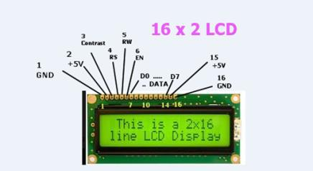

1. liquid-crystal display (LCD) is a flat-panel display or other electronically modulated optical device that uses the light-modulating properties of liquid crystals. Liquid crystals do not emit light directly, instead using a backlight or reflector to produce images in colour or monochrome. LCDs are available to display arbitrary images (as in a general-purpose computer display) or fixed images with low information content, which can be displayed or hidden, such as preset words, digits, and 7-segment displays, as in a digital clock. They use the same basic technology, except that arbitrary images are made up of a large number of small pixels, while other displays have larger elements.

**DC motor:**

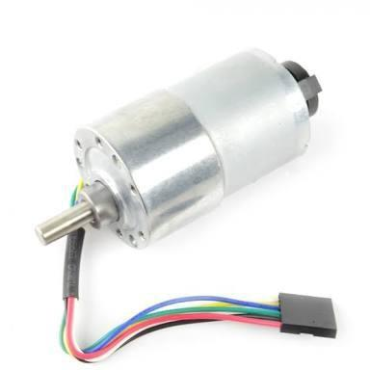

A Dc Motor is any of a class of rotary electrical machines that converts direct current electrical energy into mechanical energy. The most common types rely on the forces produced by magnetic fields. Nearly all types of DC motors have

some internal mechanism, either

electromechanical or electronic, to periodically change the direction of current flow in part of the motor.

**Buzzer:**

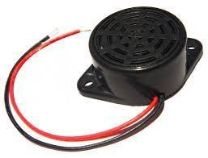

Buzzer or Beeper is an audio signalling device,[1] which may be mechanical, electromechanical, or piezoelectric (piezo for short). Typical uses of buzzers and beepers include alarm devices, timers, and confirmation of user input such as a mouse click or keystroke.

**BLOCK DIAGRAM**:

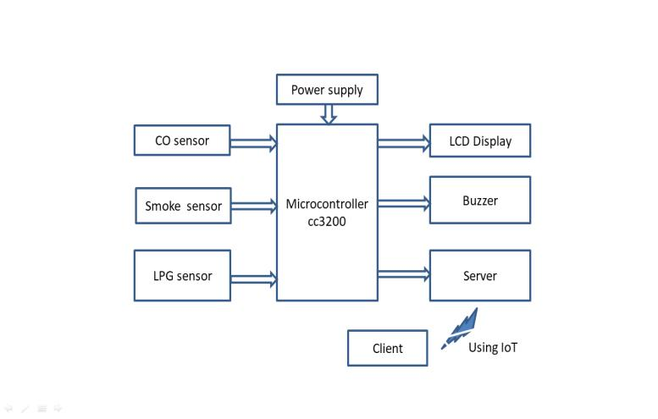

Fig a. block diagram of the system

**FLOW CHART:**

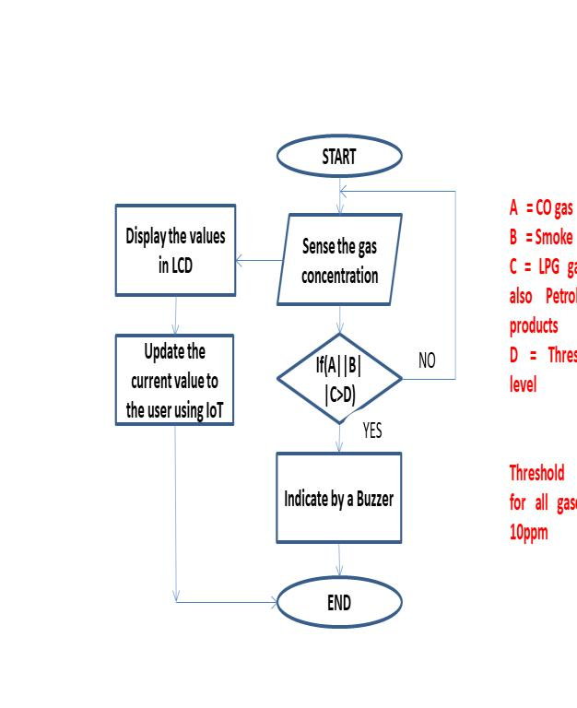

Fig b.flowchart of the system

**METHODOLOGY:**

This block diagram shows the outlay of the entire paper which has been discussed above the hardware requirements is quite limited and easily available as well as less feasible. In this system, an unmanned moving vehicle is continuously roaming around the particular area. Gas sensors are embedded on the moving vehicle. Using

gas sensors, the concentration of the gas will be sensed and detected by the gas sensors. It compares the detected value with the threshold value and it indicates by a buzzer. And the system continuously updates about the gas level in the LCD and web page using IoT.

**CONCLUSION:**

The proposed system makes the gas detection and also wirelessly transfers alert notification to the user. Unmanned moving vehicle has been designed for the use as a payload on the vehicle in order to provide gas measurement with adaptive resolution to accomplish an autonomous search for a toxic gas leakage. The use of energia software makes the system more efficient with required input and output gas sensors. Our proposed system is absolutely ethical for the application. Easy access and control makes the system very useful.

**REFERENCES :**

[1] Asmita Varma, Prabhakar S,

Kayalvizhi Jayavel,”Gas Leakage

Detection and Smart Alerting and Predection”, IEEE 2017.

[2] Rohan Chandra Pandey,Manish

Varma,Lumesh Kumar Sahu,”Internet Of

Things(IOT) Based Gas Leakage

Monitoring and Alerting System With MQ-2 Sensor”.IJEDR 2016.

1. Anandhakrishnan S, Deepesh Nair,Rakesh K,Sampath K,Gayathri S

Nair,”IOT Based Smart Gas Monitoring System” .ERTEEI 2017.

1. Heru Supriyona, Ahmad Nur Hadi

“Desinging A Wheeled Robot Model For Flammable Gas Leakage Tracking”

1. Utkarsh Bharade, Vineet Jain, Sourabh Chavan,Shubham Bangade,Prof.Jayashree

Mahajan” Gas Leakage Detection,Alerting and Monitoring using IoT”. IJAERD,

Volume 4,Issue 12 ,December-2017.

[6]ShrutiBhoir,Snehanjali

Goregaonkar,Prof.Shilpa Satre” IoT Based

Gas Detection System “ .IJESC, Volume

7, Issue 4,2017.

* 1. Luay Fraiwan, Khaldon Lweesy, Aya Bani –Salma, Nour Mani “A Wireless

Home Safety Gas Leakage Detection

System”. IEEE-2011.

1. Vanesa Gallego, Maurizio Rossi,

Davide Brunelli ”Unmanned aerial gas leakage localization and mapping using microdrons”. IEEE-2015.

1. Harshada Navale, Prof.B.V.Pawer,

“ArmBasedGasMonitoring

System”.International Journal Of Scientific

&Technology Research Volume 3,Issue 6,June 2014.

1. D.S Lee,D.D Lee,S.W.Ban,M.Lee,

Y.T kim,”SnO2 gas sensing array for combustibleand explosive gas leakage

recognition,” IEEE J.,Vol.2,pp.140-149,2002.

sensors